MECHATRONIC SYSTEM INTEGRATION
(MCTA 3203)
SEMESTER 1, 2026/2027
EXPERIMENT 1
DESIGNING A DIGITAL LOGICAL SYSTEM WITH A 7 SEGMENT DISPLAY
(MCTA 3203)
SECTION 1
GROUP 12
NO. | MATRIC NO. | NAME
1 | 2410405 | MUHAMMAD FATHI BIN MUHAMMAD SABRI
2 | 2217461 | TAHSIN TAHMID
3 | 2414951 | MUHAMMAD SYAHRUL BIN OMAR NAGESWARAN

SUBMISSION DATE : 12th OCTOBER 2026

Abstract:

The report details the design of a digital logic system that performs Number sequencing from 0 to 9, using an Arduino Uno microcontroller as the processing unit, a Common Cathode 7-Segment Display as the digital output, and other elements like a push button for specific tasks. The microcontroller is set up to use its GPIO pins, specifically the DI/O to send output to the 7-Segment display using parallel signaling by mapping each display segment separately. The first part encompasses a number sequencing counter, which counts from 0 to 9 with a delay of 1 second and a void loop function, while the second part of our experiment uses a void loop function with nested if functions to process manual push button inputs, in which case two different state transitions are achieved: an increment button that advances the count and a reset button which asynchronous forces the system back to the initial zero. System testing has demonstrated 100% counting accuracy for both parts of the experiment. However, the main technical limitation encountered was using the delay() function for this debouncing. Because delay() temporarily pauses the entire program, the system occasionally misses inputs if the buttons are pressed too fast. This can be counteracted by replacing these delays with a timer based on millis(), or setting up hardware interrupts. This would stop the Arduino from freezing between presses and make the counter much more responsive.

Section | Content | Page
1 | Cover Page
2 | Abstract | 1
3 | Table of Contents | 2-3
4 | PART 1: Continuous Loop Counter  A. Introduction & Theory, B. Materials & Equipment, C. Experimental Setup, D. Methodology & Program Logic, E. Data Collection, F. Results & Discussion, G. Conclusion | 3-8
5 | PART 2: Interactive Push Button Counter  A. Introduction & Theory, B. Materials & Equipment, C. Setup & Assembly, D. Methodology & Program Logic, E. Data Collection, F. Results & Discussion, G. Conclusion | 8-13
6 | Recommendations | 13
7 | Question | 13
8 | References | 13
9 | Appendices | 14-18
10 | Acknowledgement | 19
11 | Student Declaration | 19-20

PART 1: Continuous Loop Counter

1.0 INTRODUCTION & THEORY

This experiment investigates the usage of a 7-segment display, digital logic systems, and electronic circuit interfaces. The goal is to connect an Arduino microcontroller to a common cathode 7-segment display in order to visually produce a particular numbered sequence from 0 to 5. A logic HIGH signal is needed to ignite each segment (A through G) in a common cathode display since the cathodes of all the LEDs are connected together (Floyd, 2015). It is hypothesised that a steady, continuous visual loop of numbers will be produced by sequentially adjusting the digital output pins using programmed delays.

1.1 MATERIALS AND EQUIPMENT

- Arduino Uno board
- Common cathode 7-segment display
- 220-ohm resistors (7 of them)
- Jumper wires
- Breadboard
- PC with Arduino IDE installed

1.2 EXPERIMENTAL SETUP

- Connect each of the 7 segments (a, b, c, d, e, f, g) of the display to separate digital pins on the Arduino from D0 to D6.
- Connect the common cathode pin of the display to one of the GND (ground) pins on the Arduino.
- Use the 220-ohm resistors to connect each of the segment pins to the Arduino pins to limit the current.

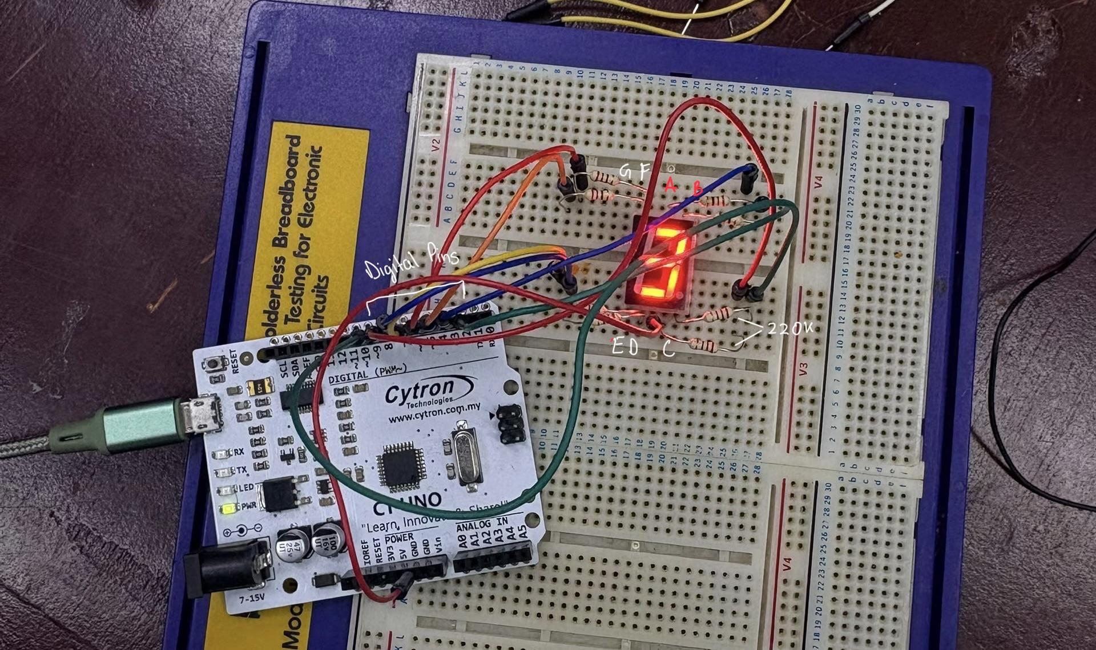

Schematic Diagram Part 1

1.3 METHODOLOGY & PROGRAMMING LOGIC

- Pin Configuration: Connect the digital pins of the Arduino to the appropriate 7-segment display inputs. D3 (Segment A), D2 (Segment B), D8 (Segment C), D7 (Segment D), D6 (Segment E), D5 (Segment F), and D4 (Segment G) are the pin assignments.
- Initialization: To allow signals to be transmitted from the microcontroller to the display, define all designated digital pins as standard outputs in the setup() function.
- State Reset Function: Create a modular function called clearSegments() that writes a LOW logic state to each segment pin. In order to make sure that no LEDs from the previous loop iteration are still lit, this runs before drawing a new digit.
- Digit Generation Logic: Create a displayDigit (int digit) function using a switch case design. The equivalent case writes a HIGH logic state to the precise pin combination needed to visually create an integer when it is supplied to the function.
- Execution Loop: Use a for loop to iterate an integer i from 0 to 9 inside the main loop() method. Before moving on to the next sequential digit, the loop calls displayDigit(i), pauses using delay(1000), and holds the visual result for precisely 1000 milliseconds (1 second).

Arduino C++ firmware Part 1

const int segmentA = 3;
const int segmentB = 2;
const int segmentC = 8;
const int segmentD = 7;
const int segmentE = 6;
const int segmentF = 5;
const int segmentG = 4;

void setup() {
pinMode(segmentA, OUTPUT);
pinMode(segmentB, OUTPUT);
pinMode(segmentC, OUTPUT);
pinMode(segmentD, OUTPUT);
pinMode(segmentE, OUTPUT);
pinMode(segmentF, OUTPUT);
pinMode(segmentG, OUTPUT);
}

void clearSegments() {
digitalWrite(segmentA, LOW);
digitalWrite(segmentB, LOW);
digitalWrite(segmentC, LOW);
digitalWrite(segmentD, LOW);
digitalWrite(segmentE, LOW);
digitalWrite(segmentF, LOW);
digitalWrite(segmentG, LOW);
}

void displayDigit(int digit) {
clearSegments();
switch(digit) {
case 0: digitalWrite(segmentA,HIGH); digitalWrite(segmentB,HIGH);
digitalWrite(segmentC,HIGH); digitalWrite(segmentD,HIGH);
digitalWrite(segmentE,HIGH); digitalWrite(segmentF,HIGH); break;
case 1: digitalWrite(segmentB,HIGH); digitalWrite(segmentC,HIGH); break;
case 2: digitalWrite(segmentA,HIGH); digitalWrite(segmentB,HIGH);
digitalWrite(segmentG,HIGH); digitalWrite(segmentE,HIGH);
digitalWrite(segmentD,HIGH); break;
case 3: digitalWrite(segmentA,HIGH); digitalWrite(segmentB,HIGH);
digitalWrite(segmentC,HIGH); digitalWrite(segmentD,HIGH);
digitalWrite(segmentG,HIGH); break;
case 4: digitalWrite(segmentF,HIGH); digitalWrite(segmentG,HIGH);
digitalWrite(segmentB,HIGH); digitalWrite(segmentC,HIGH); break;
case 5: digitalWrite(segmentA,HIGH); digitalWrite(segmentF,HIGH);
digitalWrite(segmentG,HIGH); digitalWrite(segmentC,HIGH);
digitalWrite(segmentD,HIGH); break;
case 6: digitalWrite(segmentA,HIGH); digitalWrite(segmentF,HIGH);
digitalWrite(segmentE,HIGH); digitalWrite(segmentD,HIGH);
digitalWrite(segmentC,HIGH); digitalWrite(segmentG,HIGH); break;
case 7: digitalWrite(segmentA,HIGH); digitalWrite(segmentB,HIGH);
digitalWrite(segmentC,HIGH); break;
case 8: digitalWrite(segmentA,HIGH); digitalWrite(segmentB,HIGH);
digitalWrite(segmentC,HIGH); digitalWrite(segmentD,HIGH);
digitalWrite(segmentE,HIGH); digitalWrite(segmentF,HIGH);
digitalWrite(segmentG,HIGH); break;
case 9: digitalWrite(segmentA,HIGH); digitalWrite(segmentB,HIGH);
digitalWrite(segmentC,HIGH); digitalWrite(segmentD,HIGH);
digitalWrite(segmentF,HIGH); digitalWrite(segmentG,HIGH); break;
}
}

void loop() {
for(int i=0; i<=9; i++) {
displayDigit(i);
delay(1000); // 1 second delay
}
}

1.4 DATA COLLECTION & ANALYSIS

Digit Output | Seg A (Pin 3) | Seg B (Pin 2) | Seg C (Pin 8) | Seg D (Pin 7) | Seg E  (Pin 6) | Seg F  (Pin 5) | Seg G (Pin 4)
0 | HIGH | HIGH | HIGH | HIGH | HIGH | HIGH | LOW
1 | LOW | HIGH | HIGH | LOW | LOW | LOW | LOW
2 | HIGH | HIGH | LOW | HIGH | HIGH | LOW | HIGH
3 | HIGH | HIGH | HIGH | HIGH | LOW | LOW | HIGH
4 | LOW | HIGH | HIGH | LOW | LOW | HIGH | HIGH
5 | HIGH | LOW | HIGH | HIGH | LOW | HIGH | HIGH
6 | HIGH | LOW | HIGH | HIGH | HIGH | HIGH | HIGH
7 | HIGH | HIGH | HIGH | LOW | LOW | LOW | LOW
8 | HIGH | HIGH | HIGH | HIGH | HIGH | HIGH | HIGH
9 | HIGH | HIGH | HIGH | HIGH | LOW | HIGH | HIGH

Table 1.1: Logic State Mapping for 7-Segment Output (0-9)

1.5 RESULTS & DISCUSSION

A continuous numerical loop from 0 to 9 was successfully displayed on the 7-segment display with the hardware configuration. Each number from 0 to 9 was lighted with clear segment definition and no remaining ghosting using digital pins D2 through D8 mapped to segments B, A, G, D, E, F, and C, respectively.
- Performance vs. Hypothesis: The hypothesis was entirely supported by the empirical performance. After holding each digit for precisely 1000 milliseconds, the display used clearSegments() to reset all segments before drawing the subsequent digit.
- Signal Handling & Timing Analysis: The microcontroller keeps stable pin states in between transitions since the loop makes use of blocking delay (1000) calls. Because the current flow through the 220-ohm current-limiting resistors stayed consistent throughout each 1-second holding window, the hardware execution showed stable output with no discernible flickering.
- Error Sources & Limitations:
- Blocking Code Execution: During the delay period, the microcontroller cannot accept real-time inputs or handle other activities due to the delay(1000) mechanism.
- Microcontroller Oscillator Variance: The timing tolerance of standard Arduino Uno ceramic resonators is about +- 0.5%, which causes a slight drift over long operating runs.
- Breadboard Connection Resistance: The LED brightness in segments A through G may be slightly uneven due to small voltage drops caused by loose jumper leads on the breadboard.

Video Evidence of Part 1: Video of Part 1

1.6 CONCLUSION

In Part 1, the direct digital pin control interface between an Arduino Uno and a common cathode 7-segment display was successfully verified. The modular programming method combining clearSegments() with a switch case within displayDigit() proved effective at preventing display artifacts and systematically cycling digits from 0 to 9 at 1-second intervals. Important lessons learned include the importance of organised clearing functions before writing new pin states and the requirement of positive active-HIGH logic for common cathode displays.

PART 2: Interactive Push Button Counter
2.0 INTRODUCTION & THEORY
The second part of the experiment demonstrates the use of two push buttons integrated with our previous logic setup to take a sort of manual control of the number sequencing. Here, the goal is to display incrementing numbers from 0 until 5 on the 7-segment display but instead of systematic cycling through the numbers, the push buttons will be used as increment and reset inputs. The hypothetical desired outcome is upon pressing the push button which is assigned as increment, the number will increment into the next, and with the press of the reset button, the displayed number will be reset to 0 and show on the 7-segment cathode display.

2.1 MATERIALS AND EQUIPMENT
- Arduino Uno board
- Common cathode 7-segment display
- 2 Push-buttons
- 220-ohm resistors (7)
- 10-ohm resistors (2)
- Jumper wires
- Breadboard
- PC with Arduino IDE installed
2.2 EXPERIMENTAL SETUP

- Connect each of the 7 segments (a, b, c, d, e, f, g) of the display to separate digital pins on the Arduino from D0 to D6.
- Connect the common cathode pin of the display to one of the GND (ground) pins on the Arduino.
- Use the 220-ohm resistors to connect each of the segment pins to the Arduino pins to limit the current.
- Connect one leg of each pushbutton to a separate digital pin (e.g., D9 for increment and D10 for reset).
- Connect the diagonally opposite leg of each pushbutton to GND.
- Use 10K-ohm pull-up resistors for each pushbutton by connecting one end of each resistor to the same digital pin as the button, and the other end to the 5V output of the Arduino.

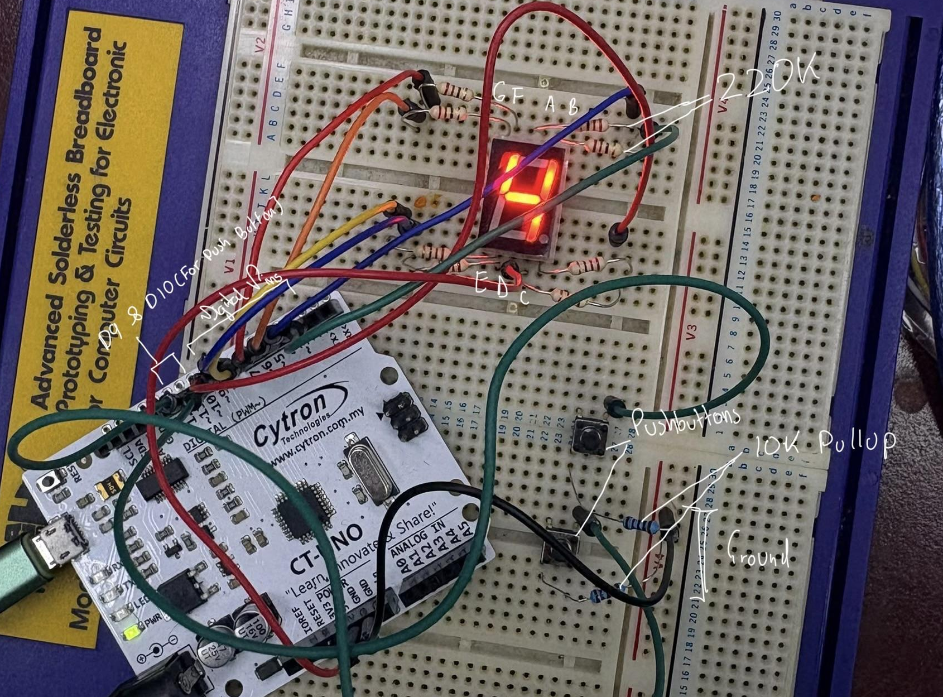

Schematic Diagram Part 2
2.3 METHODOLOGY & PROGRAMMING LOGIC
Circuit Integration & Logic Flow:
To implement manual control, the microcontroller must continuously poll the designated digital input pins (e.g., D9 and D10) connected to the push buttons. Because the circuit utilizes 10K-ohm pull-up resistors, the input pins read a ⁠HIGH⁠ logic state by default. When a button is pressed, the circuit closes to ground, pulling the pin state to ⁠LOW(Arduino, n.d.).
The firmware relies on state-change detection (edge detection) rather than simply checking the current state. This ensures that holding the button down only registers as a single increment command. The logic flow operates as follows:
1. Read Inputs: The ⁠loop()⁠ continuously reads the state of the increment and reset buttons.
2. Evaluate Increment: If the increment button transitions from ⁠HIGH⁠ to ⁠LOW⁠, a counter variable is increased by 1. If the counter exceeds 5, it is intentionally held at 5 or wrapped back to 0 (depending on specific operational requirements; here, it is capped/wrapped at 5).
3. Evaluate Reset: If the reset button transitions from ⁠HIGH⁠ to ⁠LOW⁠, the counter variable is immediately forced to 0.
4. Update Display: The ⁠displayDigit()⁠ function from Part 1 is called, passing the current counter variable to update the 7-segment output.

2.4 DATA COLLECTION & ANALYSIS
Although the experimental procedure suggested utilizing the Arduino IDE Serial Monitor for data collection, empirical visual observation of the 7-segment hardware was used as the primary metric for this phase of the experiment.
If the Serial Monitor had been initialized with standard print commands, the system would have provided real-time diagnostic telemetry, including:
- Raw Input States: Continuous monitoring of the HIGH/LOW voltage transitions on pins D9 and D10.
- Variable Tracking: Real-time logging of the internal counter integer to verify software math aligns with hardware output.
- Mechanical Bounce Signatures: Erratic logic fluctuations caused by the physical switch, which were corrected by software debounce.
In the absence of serial logging, data collection relied on observing the physical hardware's response to manual inputs. Table 2.1 outlines the observed logical state mapping based on these physical responses.

Table 2.1: Logic State Observations for Button Inputs

Current Display | Increment Button | Reset Button | Resulting Display | System Action
N (0 to 4) | Pressed (LOW) | Unpressed (HIGH) | N+1 | Counter increments, display updates.
5 | Pressed (LOW) | Unpressed (HIGH) | 0 | Counter exceeds limit and wraps to 0.
Any Number | Unpressed (HIGH) | Pressed (LOW) | 0 | Hard reset is triggered.
Any Number | Held Down | Unpressed (HIGH) | No Change | System waits for release before registering again
Any Number | Unpressed (HIGH | Unpressed (HIGH) | No Change | System idles.

2.5 RESULTS & DISCUSSION
Upon hardware assembly and firmware upload, the manual controls operated as designed. Pressing the increment button advanced the numerical display sequentially, wrapping back to zero after reaching 5. During testing, the hardware displayed a clear "4" mid-sequence without flickering or ghosting. The reset function successfully interrupted the sequence at any point, instantly returning the display to '0'.
Performance vs. Hypothesis:
The system met all hypothetical outcomes. Integrating event-driven logic successfully replaced Part 1's automated time-delay loop, proving that external digital inputs can reliably control hardware outputs.
Error Sources & Signal Noise Analysis:
Mechanical switches inherently suffer from "contact bounce," where internal metal contacts bounce for a few milliseconds upon actuation (Ganssle, 2004). Unmitigated, the microcontroller reads these as multiple rapid inputs, causing erratic counting. This was resolved using a 50-millisecond software debounce ⁠delay()⁠ after detecting a state change, allowing the contacts to mechanically settle and ensuring stable counting.
Limitations:
Blocking Debounce Logic: Relying on ⁠delay(50)⁠ for software debouncing temporarily halts the microcontroller, preventing it from processing simultaneous inputs or other background tasks during that 50-millisecond window.
Lack of Hardware Filtering: Relying solely on software to clean the signal is less robust than hardware debouncing (e.g., using RC low-pass filters or Schmitt triggers), which would condition the electrical signal before it reaches the microcontroller.
Omission of Serial Telemetry: The failure to initialize the Serial Monitor prevented the collection of quantitative data regarding the switch's mechanical bounce duration, restricting the analysis entirely to empirical visual observations.
Video Evidence of Part 2: Video of Part 2

2.6 CONCLUSION
In the second part we have successfully demonstrated that it is possible to transition a digital circuit from a passive and time based loop to an interactive and user input driven system. We have achieved this by the implementation of two push buttons with our previous circuit with the help of 10k pullup resistors, which has helped us achieve manual control over the logic circuit. The most valuable take away from this part of the experiment is the learning curve of conditioning real world hardware inputs, namely managing switch bounce using delays and debounce algorithms, teaching us to bridge the gap between physical hardware and programming logic.While the experiment had minor limitations such as the omission of serial data logging and a reliance on blocking code for debouncing it ultimately proved that systematic digital outputs can be reliably controlled and reset by external physical input

RECOMMENDATIONS

Additional displays for multi-digit projects could expand the experiment's capability. Furthermore, switching from a conventional 7-segment display to an I2C LCD might be investigated. An I2C LCD uses specific communication protocols and needs fewer pins than a matrix LED or 7-segment display.

QUESTION

How can you interface an I2C LCD with Arduino? Explain the coding principle behind it compared to a 7-segment display and a matrix LED.
- Yes, by connecting I2C LCD with four pins on arduino (VCC, GND, SDA and SCL). I2C LCD and Arduino sends data to each other in packets one by one through a single lane and by using specialized library (LiquidCrystal_I2C) they can function right away, unlike 7-segment display and matrix LED which needs to define the pin for each of the number LED's lights in their coding.

REFERENCES
Arduino. (n.d.). Digital pins. Arduino Documentation. Retrieved October 11, 2026, from https://docs.arduino.cc/learn/microcontrollers/digital-pins
Mechatronics System Integration (MCTA3203) Week 2: Digital Logic System (ver. 2) [Laboratory manual].
Floyd, T. L. (2015). Digital fundamentals (11th ed.). Pearson.
Ganssle, J. G. (2004). A guide to debouncing. The Ganssle Group. http://www.ganssle.com/debouncing.htm

APPENDICES

Appendix A(Arduino C++ firmware Part 1)

const int segmentA = 3;
const int segmentB = 2;
const int segmentC = 8;
const int segmentD = 7;
const int segmentE = 6;
const int segmentF = 5;
const int segmentG = 4;

void setup() {
pinMode(segmentA, OUTPUT);
pinMode(segmentB, OUTPUT);
pinMode(segmentC, OUTPUT);
pinMode(segmentD, OUTPUT);
pinMode(segmentE, OUTPUT);
pinMode(segmentF, OUTPUT);
pinMode(segmentG, OUTPUT);
}

void clearSegments() {
digitalWrite(segmentA, LOW);
digitalWrite(segmentB, LOW);
digitalWrite(segmentC, LOW);
digitalWrite(segmentD, LOW);
digitalWrite(segmentE, LOW);
digitalWrite(segmentF, LOW);
digitalWrite(segmentG, LOW);
}

void displayDigit(int digit) {
clearSegments();
switch(digit) {
case 0: digitalWrite(segmentA,HIGH); digitalWrite(segmentB,HIGH);
digitalWrite(segmentC,HIGH); digitalWrite(segmentD,HIGH);
digitalWrite(segmentE,HIGH); digitalWrite(segmentF,HIGH); break;
case 1: digitalWrite(segmentB,HIGH); digitalWrite(segmentC,HIGH); break;
case 2: digitalWrite(segmentA,HIGH); digitalWrite(segmentB,HIGH);
digitalWrite(segmentG,HIGH); digitalWrite(segmentE,HIGH);
digitalWrite(segmentD,HIGH); break;
case 3: digitalWrite(segmentA,HIGH); digitalWrite(segmentB,HIGH);
digitalWrite(segmentC,HIGH); digitalWrite(segmentD,HIGH);
digitalWrite(segmentG,HIGH); break;
case 4: digitalWrite(segmentF,HIGH); digitalWrite(segmentG,HIGH);
digitalWrite(segmentB,HIGH); digitalWrite(segmentC,HIGH); break;
case 5: digitalWrite(segmentA,HIGH); digitalWrite(segmentF,HIGH);
digitalWrite(segmentG,HIGH); digitalWrite(segmentC,HIGH);
digitalWrite(segmentD,HIGH); break;
case 6: digitalWrite(segmentA,HIGH); digitalWrite(segmentF,HIGH);
digitalWrite(segmentE,HIGH); digitalWrite(segmentD,HIGH);
digitalWrite(segmentC,HIGH); digitalWrite(segmentG,HIGH); break;
case 7: digitalWrite(segmentA,HIGH); digitalWrite(segmentB,HIGH);
digitalWrite(segmentC,HIGH); break;
case 8: digitalWrite(segmentA,HIGH); digitalWrite(segmentB,HIGH);
digitalWrite(segmentC,HIGH); digitalWrite(segmentD,HIGH);
digitalWrite(segmentE,HIGH); digitalWrite(segmentF,HIGH);
digitalWrite(segmentG,HIGH); break;
case 9: digitalWrite(segmentA,HIGH); digitalWrite(segmentB,HIGH);
digitalWrite(segmentC,HIGH); digitalWrite(segmentD,HIGH);
digitalWrite(segmentF,HIGH); digitalWrite(segmentG,HIGH); break;
}
}

void loop() {
for(int i=0; i<=9; i++) {
displayDigit(i);
delay(1000);
}
}

Appendix B (Arduino C++ firmware Part 2)

const int segmentA = 3;
const int segmentB = 2;
const int segmentC = 8;
const int segmentD = 7;
const int segmentE = 6;
const int segmentF = 5;
const int segmentG = 4;

const int buttonIncrement = 9;
const int buttonReset = 10;

int currentDigit = 0;
int lastIncState = HIGH;
int lastResState = HIGH;

void setup() {
pinMode(segmentA, OUTPUT);
pinMode(segmentB, OUTPUT);
pinMode(segmentC, OUTPUT);
pinMode(segmentD, OUTPUT);
pinMode(segmentE, OUTPUT);
pinMode(segmentF, OUTPUT);
pinMode(segmentG, OUTPUT);

// buttons have physical 10k pull-up resistors wired
pinMode(buttonIncrement, INPUT);
pinMode(buttonReset, INPUT);

// show 0 at startup
displayDigit(currentDigit);
}

void clearSegments() {
digitalWrite(segmentA, LOW);
digitalWrite(segmentB, LOW);
digitalWrite(segmentC, LOW);
digitalWrite(segmentD, LOW);
digitalWrite(segmentE, LOW);
digitalWrite(segmentF, LOW);
digitalWrite(segmentG, LOW);
}

void displayDigit(int digit) {
clearSegments();
switch(digit) {
case 0: digitalWrite(segmentA,HIGH); digitalWrite(segmentB,HIGH);
digitalWrite(segmentC,HIGH); digitalWrite(segmentD,HIGH);
digitalWrite(segmentE,HIGH); digitalWrite(segmentF,HIGH); break;
case 1: digitalWrite(segmentB,HIGH); digitalWrite(segmentC,HIGH); break;
case 2: digitalWrite(segmentA,HIGH); digitalWrite(segmentB,HIGH);
digitalWrite(segmentG,HIGH); digitalWrite(segmentE,HIGH);
digitalWrite(segmentD,HIGH); break;
case 3: digitalWrite(segmentA,HIGH); digitalWrite(segmentB,HIGH);
digitalWrite(segmentC,HIGH); digitalWrite(segmentD,HIGH);
digitalWrite(segmentG,HIGH); break;
case 4: digitalWrite(segmentF,HIGH); digitalWrite(segmentG,HIGH);
digitalWrite(segmentB,HIGH); digitalWrite(segmentC,HIGH); break;
case 5: digitalWrite(segmentA,HIGH); digitalWrite(segmentF,HIGH);
digitalWrite(segmentG,HIGH); digitalWrite(segmentC,HIGH);
digitalWrite(segmentD,HIGH); break;
}
}

void loop() {
int incState = digitalRead(buttonIncrement);
int resState = digitalRead(buttonReset);

// check if increment button was just pressed (transition to LOW)
if (incState == LOW && lastIncState == HIGH) {
currentDigit++;

// wrap back to 0 if it goes past 5
if (currentDigit > 5) {
currentDigit = 0;
}

displayDigit(currentDigit);
delay(50); // debounce
}

// check if reset button was just pressed
if (resState == LOW && lastResState == HIGH) {
currentDigit = 0;
displayDigit(currentDigit);
delay(50); // debounce
}

// save current state for the next loop
lastIncState = incState;
lastResState = resState;
}

Appendix C

ACKNOWLEDGEMENT

We would like to express our deepest appreciation to our instructor and lab personnel for their guidance and support throughout this experiment.

STUDENTS DECLARATION

We hereby declare that the work presented in this technical report is entirely our own, except where explicitly acknowledged. We certify that in developing and completing this mechatronics project, we have strictly adhered to the standards of academic integrity and have not engaged in any form of plagiarism or unethical conduct. All sources of information, reference materials, and technical support utilized in this work have been appropriately cited and acknowledged.

Certificate of Originality and Authenticity

This is to certify that we are responsible for the work submitted in this report, that the original work is our own except as specified in the references and acknowledgment, and that the original work contained herein has not been undertaken or done by unspecified sources or persons. We hereby certify that this report has not been done by only one individual, and all of us have contributed to the report. The length of contribution to the reports by each individual is noted within this certificate. We also hereby certify that we have read and understand the content of the total report, and no further improvement on the reports is needed from any of the individual contributors to the report. We therefore agreed unanimously that this report shall be submitted for marking, and this final printed report has been verified by us.

Name: MUHAMMAD FATHI BIN MUHAMMAD SABRI
Matric : 2410405

Signature:
Read[✓]
Understand[✓]
Agree[✓]

Name: TAHSIN TAHMID
Matric : 2217461


Signature:
Read[✓]
Understand[✓]
Agree[✓]

Name: MUHAMMAD SYAHRUL BIN OMAR NAGESWARAN
Matric : 2414951

Signature:
Read[✓]
Understand[✓]
Agree[✓]

